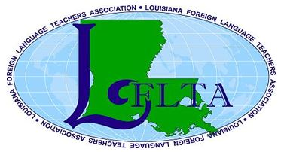
Louisiana Foreign Language Teachers’ Association
2020 Conference
Louisiana’s Got Talent!
Natchitoches Events Center
750 Second Street Natchitoches, LA 71457 / 877-238-7502
Please Print
Name:  (as you wish it to appear on badge) |  |  |  |  |  | File under what letter?
Mailing Address:
City, State, ZIP: |  |  |  |  |  | Parish:
Home Phone: |  | Work Phone: |  |  | Cell Phone:
Email:
School/Institution:
(as you wish it to appear on badge)
What is your current job title?

Language(s) you teach:
Check Level(s) you teach: | Elem. School □ |  | Middle School □ | High School □ |  | University □ | Other:
Do you teach in an Immersion Program? Yes □ No □ If so, what level(s)?

Fees for Mailed Registration or Membership Only: all fees non-refundable, no exceptions
Fee | Description | Amount
$115 | EARLY REGISTRATION: Friday lunch, Saturday workshop, and Saturday lunch. The meal fee is included and not a separate choice.  □ Please check here if you would like a vegetarian meal.  Early Mailed Registrations MUST BE postmarked by: OCTOBER 1, 2019 | $
$130 | REGULAR REGISTRATION: Friday lunch, Saturday workshop, and Saturday lunch. The meal fee is included and not a separate choice.  □ Please check here if you would like a vegetarian meal.  Mailed Registrations MUST BE postmarked by: DECEMBER 31, 2019 | $
$75 | STUDENT REGISTRATION: Friday lunch, Saturday workshop, and Saturday lunch. To qualify for Student Rate, you must be a full-time university student or student teacher. (Must present student ID at registration)  □ Please check here if you would like a vegetarian meal. | $
$25 | MEMBERSHIP ONLY (I am unable to attend but wish to be on Email mailing list.) | $

Total Amount Due | $

Make checks payable to: LFLTA

Mail check to: Georgina Cutrone, LFLTA Treasurer
PO Box 9262
Monroe, LA 71211
Please make confirmation inquiries to: lfltaboard.treasurer@gmail.com

**By registering for our 2020 Conference, members understand that their photo may be taken and used to promote LFLTA**

