Guiding Language Learning – Applying Proficiency

LFLTA Conference Workshop
January 13, 2018
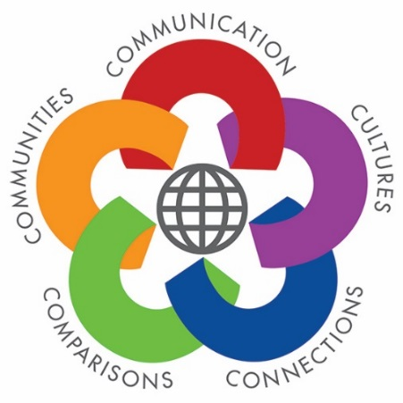 | Paul Sandrock  American Council on the  Teaching of Foreign Languages  www.actfl.org  psandrock@actfl.org | 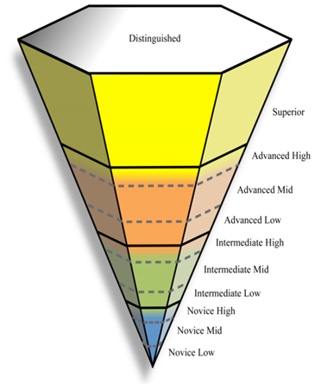
World-Readiness Standards for ACTFL Proficiency
Learning Languages (2015) Guidelines (2012)

Focus: Unwrapping Proficiency
Learning Targets:
I can describe what it takes to move from one Proficiency level to the next:
- Moving from Novice to Intermediate
- Moving from Intermediate toward Advanced

I can identify communication strategies learners need to practice to reach their next level

Focus: Applying Proficiency
Learning Target:
I can chart learners’ progress across the proficiency continuum within each unit of instruction:
- Learning Checks
- Formative Assessments
- Summative Assessments

Focus: Guiding Language Learning
Learning Targets:
I can design effective tasks to help learners develop the language functions and communication strategies they need to progress along the proficiency continuum
- Interpersonal Mode of Communication (Interacting in conversations)
- Presentational Mode of Communication (Creating messages)
- Interpretive Mode of Communication (Understanding what is heard, read, or viewed)

Key Characteristics of Novice – Intermediate – Advanced Proficiency Levels: What do you hear?

Novice level speakers can… | What does this mean for my classroom?
Intermediate level speakers can … | What does this mean for my classroom?
Advanced level speakers can … | What does this mean for my classroom?

ACTFL Proficiency Guidelines
https://www.actfl.org/publications/guidelines-and-manuals/actfl-proficiency-guidelines-2012

Sample Integrated Performance Assessment: Novice Level

Interpretive | Interpersonal | Presentational
Look at (or listen to) information from three different host families in Egypt, to find out as much as you can: Where they live, how many children they have, what activities they like to do, etc.  Then decide which family you would prefer to host you and list as many reasons as possible to explain why. | You and your partner are exchange students. It will be your first night with your host family in Egypt next week and you want to practice your conversational skills. You share pictures of your own family and you practice with your partner the kinds of questions you will ask and how you will respond. | The exchange program would like you to write a letter describing your family that the Egyptian students will read to decide on their American host family.  Provide as many details as you can to describe you and your family. Include likes, dislikes and activities.

What can you find out about each family? | Eissa Family | Mizrahi  Family | El Nabawy  Family
Where do they live?
Do they live in a house, apartment, condo, something else?
How many people live together as the family? Who are they?
What activities do they like to do?
What else can you do during homestay with this family?

Performance | Proficiency
- Language is learned and practiced in an instructional setting  - Familiar contexts and content areas  - Curriculum dependent  - Assessment is based on what was taught and practiced | - Spontaneous, non-rehearsed interaction in real-world situations  - Broad content and context in authentic situations  - Independent of curriculum or when, where, or how the language was acquired  - Assessment is based on the criteria in the ACTFL Proficiency Guidelines
How can I guide language learners to bridge from performance into proficiency?

Gradual Release of Responsibility
Student Responsibility
Teacher Responsibility
Providing Input | Sharing | Guiding | Applying
The teacher demonstrates, models, explains to make input comprehensible. As learners gain proficiency, the teacher guides them in the selection of authentic text. | The teacher scaffolds instruction and begins to guide student work. | The teacher offers support and encouragement and provides feedback. | The teacher monitors and provides feedback.
 |  |  | Learners independently demonstrate progress toward learning targets and self-assess their progress
 |  | Learners engage in pair and small group activities that allow them to interpret and express meaning for real-world purposes.
 | Learners contribute and begin to work with teacher support.
Learners engage with the content, process input.
I do | We do |  | You do
FROM: STARTALK Learner Centered Learning At A Glance document,
adapted from the Fisher & Frey model in Better Learning Through Structure Teaching.

Into the Classroom: How many ways does the teacher check students’ learning?

What are the specific tasks (assessments) that move from “I do” to “We do” to “You do”?
“I Do” | “We Do” | “You Do”

What changes in learners’ performance?

What changes in teacher’s feedback?
- Interpersonal Mode of Communication ‘

IS | IS NOT
Two-way communication | One-way communication
Spontaneous, unrehearsed | Memorized (dialogues, skits)
Negotiated: responding and reacting to what others say, asking follow-up questions to confirm understanding | Making random comments, asking unrelated, off-topic questions
Asking for/giving clarification | Giving up if you don’t understand or if others don’t understand you
Using words, phrases, sentences as appropriate to communication | Speaking in complete sentences all the time
Active listening | Daydreaming, being off-task
Using culturally appropriate language and gestures | Being unmindful of appropriate language and gestures
Staying in the target language | Sprinkling in English for words you don’t know

Targeting the Proficiency Level: Interpersonal Performance Assessments

Novice | Intermediate | Intermediate High/Advanced
Collaboration: Students develop a survey to investigate the eating habits of the class, interview students, and discuss the results to create a graph | Storytelling: Students collaborate to retell a familiar story and prepare to present it to their classmates | Debate: Circulate in the room to find students who have the most similar ideas to your ideas on a debate topic; the resulting small groups work together to create the main points they will make in a debate
Recipes: Students browse online recipes and work in pairs to change ingredients to healthier alternatives | Agreement: Students exchange text messages to determine who has the busiest week | Consensus: Students examine a blog about a news event in the target language country; identify what new information they discover and collaborate to post a reply
Introductions: Practice the first night at your host family’s home: introduce yourself, show your photos, and ask questions of each other’s family and home | Presentation: Plan and practice giving a tour of your school for the group of visiting students. What differences do you need to highlight? | Discussion: How do you change stereotypes? With your partner, examine any ideas about the target culture that have changed during your study of their language; try to identify what caused a change
Making Plans: Organize the plan for a day in a new city, agreeing on what to do first, second and last | Analysis: Is it worth it to be famous? With your partner, identify as many advantages and disadvantages as you can

Feedback Tools
Descriptive Scale Feedback: Interpersonal Communication
Move from: | 1 – 2 – 3 | Move to:
Only responds when asked |  | Volunteers comments related to the discussion
Asks random questions |  | Asks follow-up questions related to what someone else said
Gives short responses |  | Gives responses with details, reasons, explanations
Dominates the discussion |  | Invites others to give their opinions, ideas
Repeats ideas that others already contributed |  | Adds ideas, insights, additional information to make the discussion more interesting

Novice Checklist:
Task: Novice Level – Interpersonal  Performance Criteria: | I can do this on my own | I can do this with some help | I cannot do this
- I can use numbers
- I can use words for activities
- I can use words for locations
- I can use expressions to show that I agree or disagree with what my partner says
- I can ask some questions
- I can say how many times, how often, how frequently I do various things
- I can provide some description

Scoring Guide:
Moving Intermediate  toward Advanced | No opportunity  to  observe | Never or rarely | Some of the time | Most of the time | Always
Staying in the target language
Contributing equally to activity
Staying on task
Helping each other
Encouraging each other
Sharing ideas
Solving problems
Giving feedback respectfully
Accepting feedback respectfully

- Presentational Mode of Communication ‘

Targeting the Proficiency Level: Presentational Performance Assessments

 | Novice | Intermediate | Advanced
To Persuade | Record a podcast on which season is the best and why | Create a presentation based on multiple sources of information highlighting ways to promote a balanced lifestyle for teenagers. | Write a review of a movie (book) to convince others your age to see (read) it
To Inform/  Explain | Create a brochure explaining activities to do in ____, focused for students interested in arts, history, outdoor activities, or food | Post on a blog two things our school could do (do better) to respect the environment and how that will help | What part of teenage life in ____ would be the hardest for you to adapt to; explain why
To Narrate | Describe your busiest (healthiest) day of the week and why you consider it so | Post on a website hosted by the ______Tourist Office. Explain what you did on your trip; share experiences of cultural differences. | Tell about a time you dealt with stress, share the cause and how you dealt with it

- Interpretive Mode of Communication ‘

Building Performance in the Interpretive Mode

Top-Down Strategies
- Background Knowledge
- Using Context Clues
MEANING
- Discriminating between sounds and letters
- Recognizing word order patterns
- Analyzing sentence structure
- Examining parts of words to decipher meaning
Bottom-Up Strategies

Strategies to Practice and Assess Interpretive Communication

1. Receive sheet of nine photographs; listen to descriptions and identify the photograph being described (write the number of the description on the photo)

2. Use graphic organizers to guide learners’ comprehension
Who | What | When | Where | Why
Alice | Fell down a rabbit hole | She was chasing the rabbit | In Wonderland | She was very curious

http://www.carla.umn.edu/cobaltt/modules/strategies/gorganizers/EDITABLE.HTML

3. Fill in graphic organizer to identify key details
Possible Content (Predicted) | True, False, No Evidence? | If false, what is the correct information?
- Using solar energy is the best way to save electricity.
- Disposable razors are bad for the environment.
- Save water by collecting rainwater.
- Don’t drive; use a bicycle.
- Oil-generated electricity is better for the environment than using coal.
- More than half of garbage is now recycled.

RESOURCES
World-Readiness Standards for Learning Languages (2015)
http://www.actfl.org/publications/all/world-readiness-standards-learning-languages

Oral Proficiency Levels in the Workplace
https://www.actfl.org/sites/default/files/pdfs/TLE_pdf/OralProficiencyWorkplacePoster.pdf

NCSSFL-ACTFL Can-Do Statements
http://www.actfl.org/publications/guidelines-and-manuals/ncssfl-actfl-can-do-statements

ACTFL Assessment of Performance toward Proficiency in Languages (AAPPL)
http://aappl.actfl.org/

ACTFL Conversation Builder http: //aappl.actfl.org/tools; Access at: http: //aapplcb.actfl.org/

Annenberg/CPB Library
Teaching Foreign Languages K-12: A Library of Classroom Practices: http://learner.org/libraries/tfl/

ACTFL Publications (http://www.actfl.org/publications/all)
The Keys to Assessing Language Performance (Sandrock)
The Keys to Planning for Learning: Effective Curriculum, Unit, and Lesson Design (Clementi & Terrill)
The Keys to Strategies for Language Instruction (Grahn and McAlpine)
Implementing Integrated Performance Assessment (Adair Hauck,. Glisan,. Troyan)

